**CPR Outcomes**

Most patients get information about CPR from TV. Depictions of CPR on TV create overly-optimistic impressions about CPR’s effectiveness. A study1 reviewing outcomes after CPR as portrayed on *ER*, *Chicago Hope*, & *Rescue 911* found the following across 60 episodes of CPR:

* 77% of patients resuscitated on these TV shows survived the immediate arrest;
* Most cases implied long term survival; and
* Only one survivor incurred any obvious disability after CPR.

Real-life outcomes are not as positive.

Among adults who received CPR in the hospital2,3:

* 56% died during resuscitation
* 27% died before hospital discharge
* 17% survived to discharge

Among patients 65 and older who received CPR in the hospital4:

* 49% died during resuscitation (black figures, below)
* 34% died before hospital discharge (gray figures)
* 17% survived to discharge (red and green figures)
* 10% were alive one year after discharge (green figures)

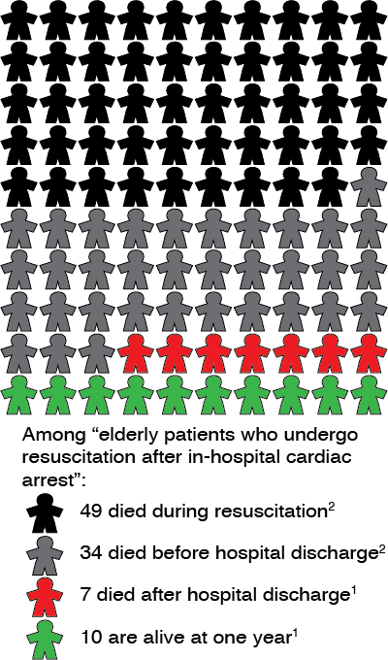

Source of images: http://www.geripal.org/2013/09/outcomes-of-in-hospital-cpr-not-as-rosy.html

Keep in mind that these numbers are averages. Survival is lower for some patient groups, better for other.

This figure illustrates the risk of experiencing cognitive disability after CPR for patients age 65+.

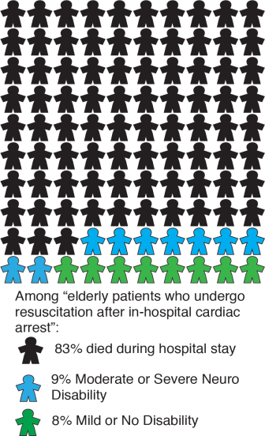



Among those who survived after CPR and had good cognitive performance before their arrest, most (86%) had good cognitive performance after CPR; some (14%) had at least moderate cognitive impairment.2

There is also a risk of not being able to return home, or being unable to care for oneself after surviving CPR. In a recent large study, 83% died during CPR or prior to discharge, 9% were discharged to an inpatient facility, 7% were discharged home, and 1% were discharged to hospice.4

______________________________________________________________

1 Diem SJ, Lantos JD, Tulsky JA. Cardiopulmonary resuscitation on television: Miracles and misinformation. N Eng J Med 1996;334: 1578-82.

2 Peberdy MA, Kaye W, Ornato JP, Larkin GL, Nadkarni V, Mancini ME, Berg RA, Nichol G, Lane-Trultt T. Cardiopulmonary resuscitation of adults in the hospital: a report of 14720 cardiac arrests from the National Registry of Cardiopulmonary Resuscitation. Resuscitation 2003:58;297-308.

3 Girotra S, Nallamothu BK, Spertus JA, Li Y, Krumholz HM, Chan PS. Trends in survival after in-hospital cardiac arrest. N Engl J Med 2012:367(20):1912-20.

4 Chan PS, Nallamothu BK, Krumholz HM, et al. Long-term outcomes in elderly survivors of in-hospital cardiac arrest. N Engl J Med 2013; 368:1019-1026.

**Related Progress Notes**

**“Life-Sustaining Treatment” note title:** This note title and standardized template is used by practitioners to document goals of care conversations with high-risk patients (or their surrogates) about the patient’s values, goals and life-sustaining treatment decisions related to current care. Health care team members without the authority to write LST progress notes and orders (e.g., nurses, social workers, chaplains, psychologists) must not use this note title. If a patient has an LST progress note in their chart, other team members may add addenda to the LST progress note if authorized to do so by local policy, and must add the attending physician or other LIP in charge of the patient’s care as an additional signer. Completed LST progress note are accessible through CWAD.

**“Life-Sustaining Treatment” orders:** LST orders are durable orders to limit life-sustaining treatment. They include Do Not Resuscitate orders, and may include orders to limit other life-sustaining treatments (e.g., invasive mechanical ventilation, artificial nutrition, transfers to the ICU). LST orders may only be written by physicians, residents, APRNs, and PAs.

**“Goals & Preferences to Inform Life-Sustaining Treatment Plan” note title:** This note title is used by team members without the authority to write LST progress notes and orders, (e.g. nurses, social workers, chaplains, psychologists) to document a discussion with a high-risk patient (or surrogate) about information pertinent to the goals of care conversation (i.e., identification of the patient’s surrogate, goals of care, preferences or questions related to services or treatments). This progress note may also be used by practitioners when goals of care have been discussed but LST decisions have not yet been made. **Note:** Facilities may use a different, locally developed note title for this purpose, and may or may not link this note to CWAD (linking is recommended). The National Center for Ethics in Health Care has developed a template for this note. <http://vaww.ethics.va.gov/CACHISResources/OptionalDevelopment.asp>

**“Out-of-Hospital Orders” note title:** This note title is used to document a current state-authorized portable order (SAPO) (e.g., POLST, MOST, MOLST). When a patient presents with a SAPO to a VHA facility, the practitioner must complete an “Out-of-Hospital Orders” progress note indicating that the Veteran presented with an authorized identifier (e.g., bracelet or necklace) or paper orders (e.g., POLST), specifying the date and jurisdiction of the SAPO, and including a description of the substance of the SAPO, describing the relevant orders. If the Veteran presents with a paper SAPO, practitioners must have the paper SAPO promptly scanned into the Veteran’s electronic health record and linked to the associated “Out-of-Hospital Orders” progress note, which is accessible through CWAD.

**“Out-of-Hospital Orders: Rescinded” note title:** This note title is used to document SAPO that are no longer applicable. Use of this note title is not mandatory, facilities must develop their own document management protocols for rescinding non-current SAPO.

VHA Handbook 1004.03, *Life-Sustaining Treatment (LST) Decisions: Eliciting, Documenting, and Honoring Patients’ Values, Goals, and Preferences\** outlines documentation requirements regarding goals of care conversations (GoCC) and LST orders. VHA Handbook 1004.04, *State-Authorized Portable Orders (SAPO) \*\**, outlines documentation requirements regarding SAPO (e.g. POLST, MOLST, MOST).

*<http://vaww.va.gov/vhapublications/ViewPublication.asp?pub_ID=4308>

**http://www1.va.gov/vhapublications/ViewPublication.asp?pub_ID=2823

**Advance Directive Documentation**

**“Advance Directive Notification and Screening” note title or other locally developed note title:** Advance directive notification and screening (ADNS), as outlined in paragraph 6 of VHA Handbook 1004.02, includes notifying patients of their rights regarding advance directives and asking patients whether they have an advance directive, would like more information about advance directives and/or would like assistance in completing an advance directive. ADNS may be documented under the recommended national note title “Advance Directive Notification and Screening” or another locally developed note title. ADNS must not be documented in an “Advance Directive Discussion”, “Advance Directive” or “Rescinded Advance Directive” progress note. Notes: The National Center for Ethics in Health Care (NCEHC) has developed an ADNS template. <http://vaww.ethics.va.gov/activities/policy.asp>.

**“Advance Directive Discussion” note title:** This note title is used to document an advance care planning discussion between a practitioner and a patient with decision-making capacity. This discussion comes after a patient has identified, during notification and screening, that they would like more information about advance directives, and includes a discussion about a patient’s values and preferences for future health care, after loss of decision-making capacity. *Advance directive notification and screening and advance care planning discussions are two separate processes that must be documented separately.* NOTE: A discussion with a high-risk patient about the patient’s values, goals, and preferences related to current care (a goals of care conversation) is documented through a separate progress note with a title established by your facility (recommended title: Goals & Preferences to Inform Life-Sustaining Treatment Plan). See

**“Advance Directive” note title:** This note title is used only to indicate that an advance directive document has been entered into the electronic record. The purpose of the “Advance Directive” note title is to link to the actual advance directive document so it is easily accessible in CWAD/Postings.An *“*Advance Directive”note is generated automatically when a VA advance directive is completed through iMedConsentTM. When an advance directive is completed on the paper form it must be manually linked to an “Advance Directive” progress note during the scanning process.

**“Rescinded Advance Directive” note title:** This note title is used to document the patient’s revocation of an advance directive. When a patient revokes an advance directive, staff should write an addendum to the “Advance Directive” progress note associated with the directive that the patient is revoking and request that the responsible party (typically, the Chief of HIMS) changes the progress note title associated with the revoked advance directive to “Rescinded Advance Directive.” Completed “Rescinded Advance Directive” notes are available in CWAD.

VHA Handbook 1004.02, *Advance Care Planning and Management of Advance Directives*, outlines advance directive documentation requirements. <http://vaww1.va.gov/vhapublications/ViewPublication.asp?pub_ID=2967>

**Documenting a Goals of Care Conversation: Sample Progress Note**

**NOTE TITLE: Goals & Preferences to Inform Life-Sustaining Treatment Plan**

*Veteran is 60 y.o. female who expressed interest in discussing goals of care during infusion clinic appointment. Veteran is calm during visit, no acute needs identified. Ambulatory with cane, has O2 with her but not wearing during this discussion. Pertinent medical history (from medical record): stage IV breast cancer with metastasis to lung, hypertension, and anxiety.*

**1. A discussion about the Veteran’s values, goals, and preferences was conducted, with the following people in attendance:**

- The Veteran

- Veteran’s Health Care Agent (named in a Durable Power of Attorney for Health Care): *[spouse]*

**2. The Veteran’s VA-authorized surrogate if/when the patient loses decision-making capacity:**

- Health Care Agent (named in Durable Power of Attorney for Health Care)

Name(s): *(spouse’s name)*

Contact Information: *XXX-XXX-XXXX*

- Alternate Health Care Agent: *(daughter’s name) YYY-YYY-YYYY*

**3. Understanding of Health:**

- There were no indications that the Veteran (or surrogate) lack understanding of the Veteran’s medical condition and prognosis; this should be confirmed by practitioner(s) in charge of the Veteran’s care.

- The Veteran (or surrogate) described the Veteran’s medical condition and prognosis as follows:

*"I know it's terminal." Veteran explained she has stage 4 breast cancer with a 1 year prognosis, possibly 2 years. She reported that she was recently in the hospital with a pleural effusion which required a thoracentesis. She stated that she was discharged to home with oxygen which she wears only at night and sometimes with activity. She said she has been having increased pain when getting out of bed in the morning.*

- The Veteran (or surrogate) has the following questions about medical condition and/or prognosis: *What will happen if breathing becomes more difficult and/or pain increases?*

**4. Values and Goals of Care:**

- Veteran’s health-related values and goals in the Veteran’s (or surrogate’s) own words:

*Values independence—“I want to stay in my own home.” Wants family to feel supported through her illness. Enjoys socializing with friends/family and caring for her horses. Faith is important to Veteran, attends church regularly—it is important for Veteran to be able to continue going to church.*

- Veteran’s (or surrogate’s) health-related concerns or worries about the future:

*Most concerned about symptoms (shortness of breath & pain) becoming worse and how this will be managed. Also concerned how increased symptoms will affect her family, worried about family seeing her “struggling” with pain. Also worried about losing independence & needing more help from family for her daily needs-- wants to stay home, but does not want to be a "burden" to family.*

**5. Discussion of Services to Support the Veteran’s Goals and Preferences**

- Information was provided about the following services: *Palliative Care*

- Veteran’s preferences related to services: *Interested/receptive to Palliative care based on goals of wanting symptoms managed and making sure family is supported.*

- Veteran’s (or surrogate’s) questions or concerns about services: *would like to discuss further with family and then talk about setting up an appointment with PCP.*

**6. Discussion of Life-Sustaining Treatments**

- Information was provided about the following life-sustaining treatments:

*CPR. Discussed handout, "Information for Patients & Families about CPR," together.*

- Veteran’s values/goals related to life-sustaining treatments:

*Veteran values her "quality of life," which she described as being at home with her family and being as independent as possible.*

- Veteran’s (or surrogate’s) questions or concerns about life-sustaining treatments:

*Based on Veteran's illness/disease process, what is her chance of survival if she receives CPR?*

**7. Additional Information About Document(s) Reflecting the Patient’s Wishes:**

*Completed VA Advance Directive in June 2016, reviewed today and continues to reflect her preferences. Document viewable in VISTA Imaging.*

**8. Follow-up Plan**

- Refer for discussion about diagnosis and prognosis. *Veteran has specific questions about what to expect with disease process & symptom management in the future (see #3 above).*

- Refer for discussion about Life-Sustaining Treatment plan and orders. *Veteran wanting more information about potential outcome of CPR based on her disease (see #6 above).*

- Refer for discussion about services. *Veteran receptive to Palliative care and would like to discuss further at next visit.*

*Adding PCP as additional signer to address the above items during appointment next week.*